1. In scrum when is testing done.

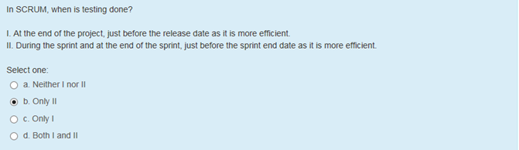

1. What is scrumban

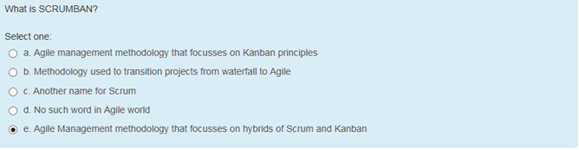

1. Identify the agile methodology which mandates engineering practices like automation, test driven – extreme programming

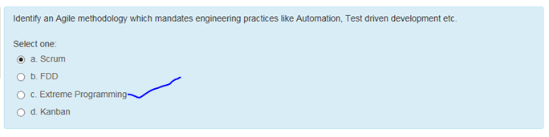

1. Identify three characteristics of Kanban – no prescribed, used more, work is done

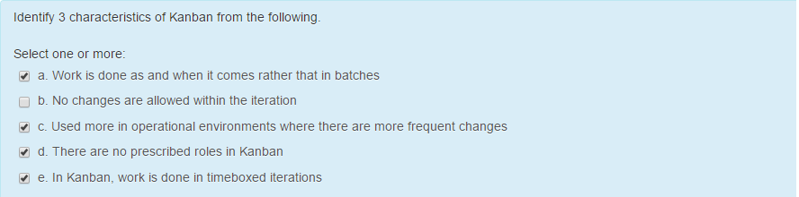

1. Maximum duration of iteration in scrum- 3 – 4 weeks
2. In scrum who is responsible for not delivering complex requirements on time – product owner
3. Which of the following meetings are not part of scrum

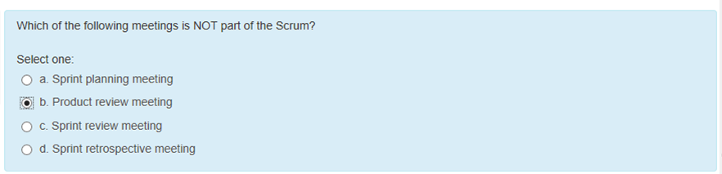

1. Scrum and Kanban can be used at the same time. True or false – True

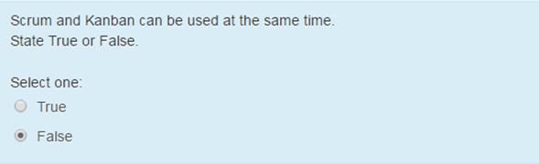

1. Automation framework enables which of the following for the test automation

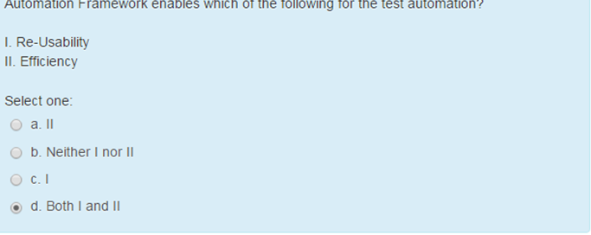

1. Why do you need to go for automation framework

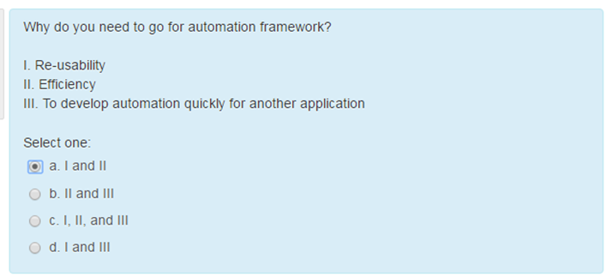

1. Disadvantages of waterfall method over agile project – 1,2 ,3

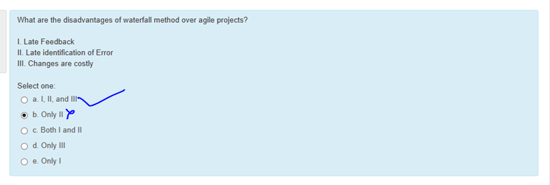

1. Scrum is

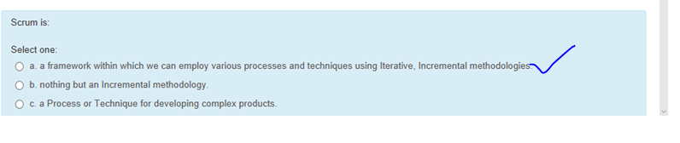

1. Velocity is a measure of which of the

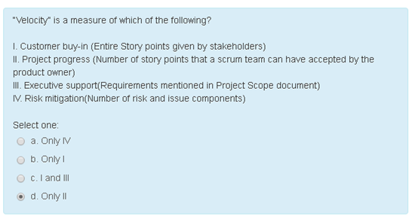

1. How should work be allocated in agile project

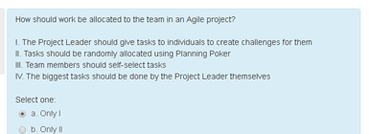

1. Extreme programming are amenable to changes within sprint

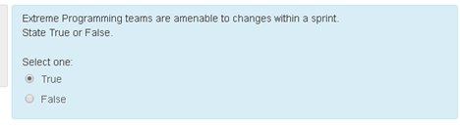

1. What would be the effects of not using automation framework during automation

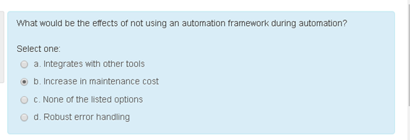

1. Suitable candidates for automation

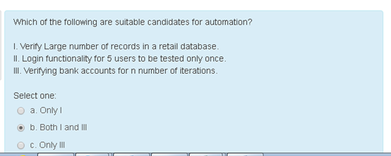

1. Burn down chart

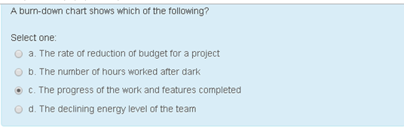

1. The potential benefits of automated testing is usually outlined in which of the following phase

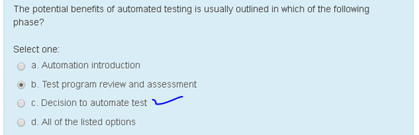

1. Basic necessities of automation

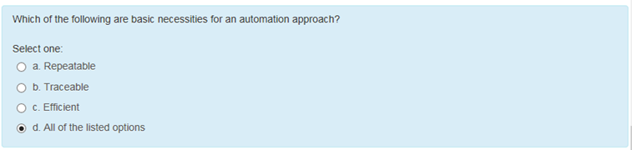

1. Automation framework is replacement for automation tool

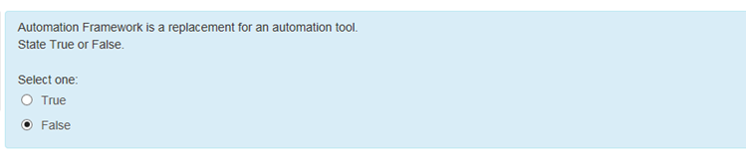

1. Best way to reduce automation cost

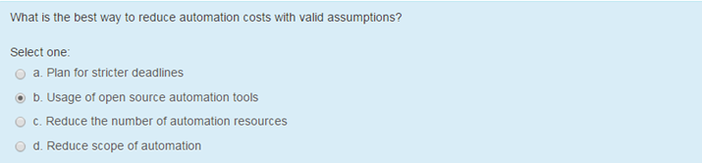

1. On what basis you will choose a framework for your tool

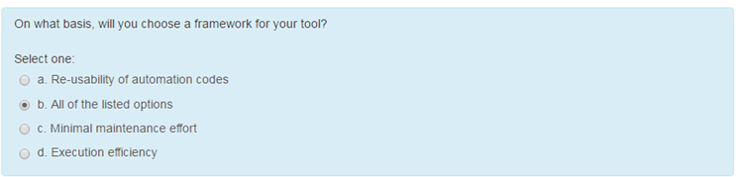

1. Test tool compatabitlity with application and test environment is

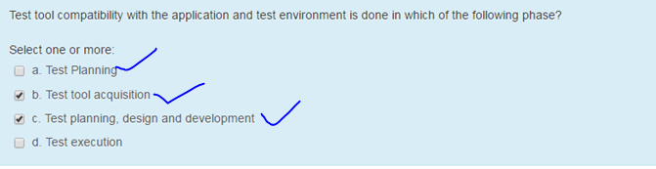

1. Automation score over manual testing

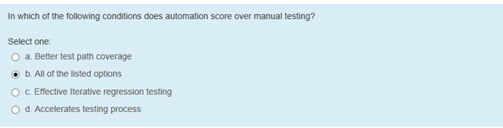

1. Not suit creation of automation test scripts

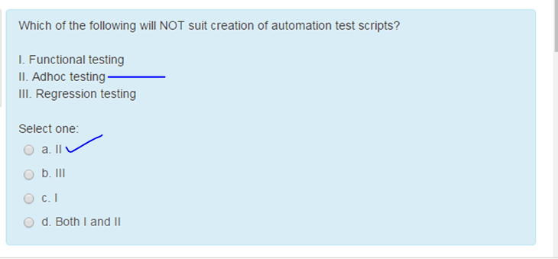

1. Each test contributes to specification of desired behavior

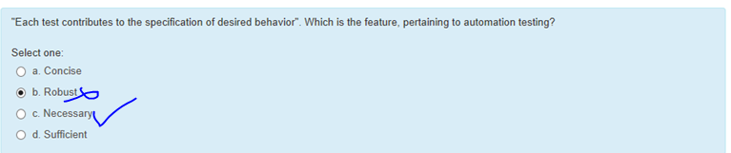

1. What is the way that devops can increase your systems security – only quick patch

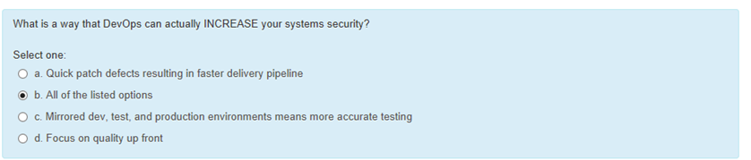 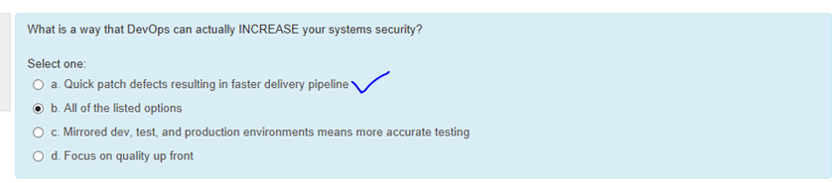

1. Categorize the waste of having multiple issue tracking system

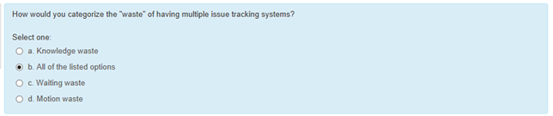

1. Key aspects or principle behind devops

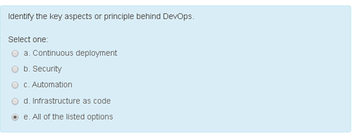

1. CRAFT framework follow which of the following approach

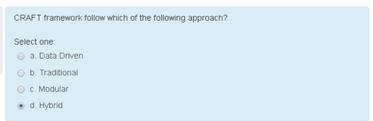

1. What role does source control play in devops org

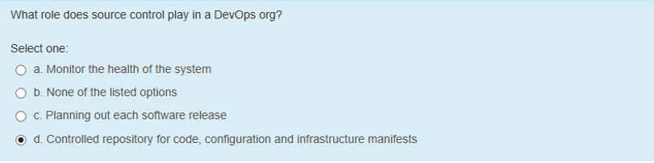

1. Popular devops tool – Nagios (&  [Icinga](https://www.icinga.org/)), Monit, ELK [Elasticsearch Logstash Kibana](https://www.elastic.co/webinars/elk-stack-devops-environment)

Consul io, Jenkins, docker, ansible, Collectd/l, Git([GitHub](http://github.com/))

1. Difference between over production waste and over processing waste

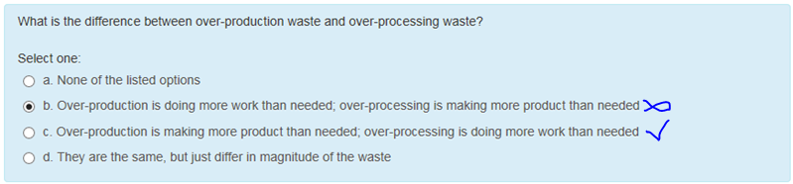

1. Successful devops requires a new team dedicated to carrying out deployment and optimization task

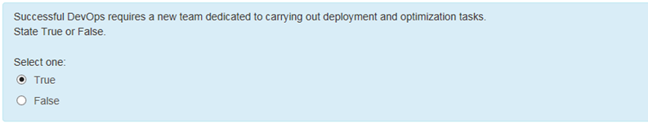

1. 2 core operations of devops with respect to application infrastructure

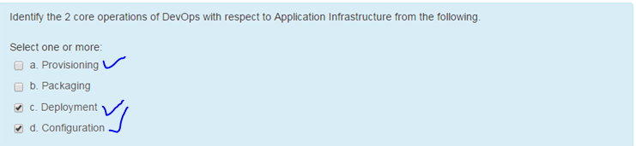

1. Collaboration tool makes the most sense for persistent information

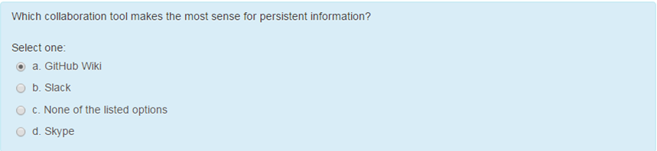

1. How does continuous deployment differ from continuous delivery

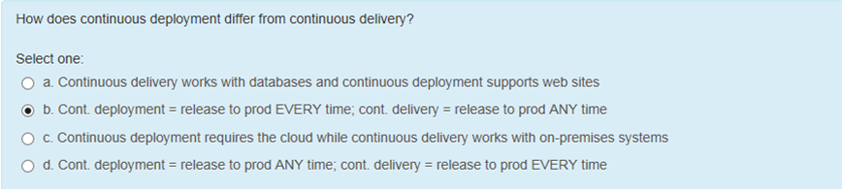

1. Inconsistent environment can be a bottleneck to flow – true
2. core operations of devops with respect to application development

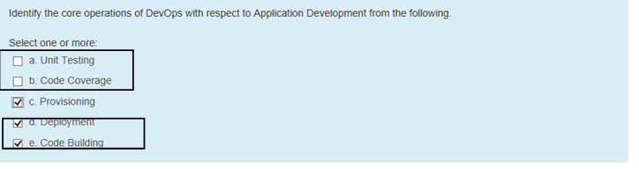

1. what is continuous testing in devops – only 2

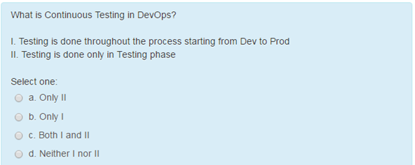

1. if a user want to display data from various modules, which type of graph – only business

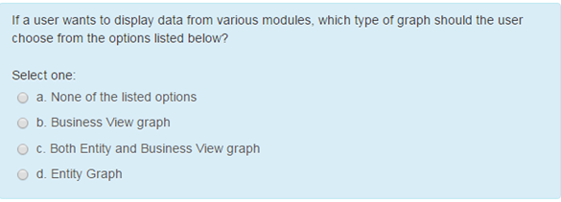

1. susan needs to define a new testing cycle under an existing release in hp alm as part of project needs. identify which side bar

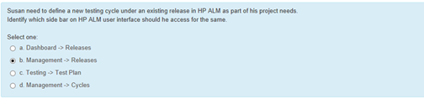

1. coverage analysis view displays which of the following information – a b c

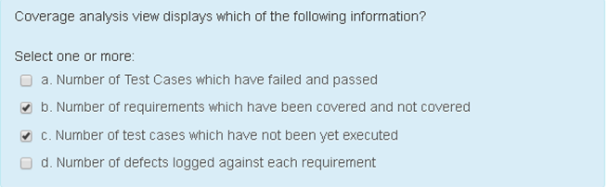

1. valid sequence of defect

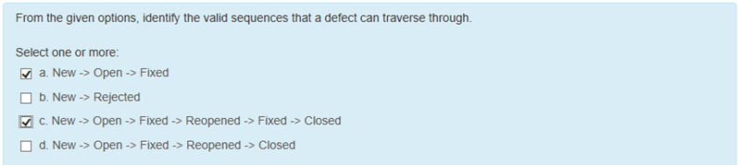

1. each time you add a new defect alm store keyword

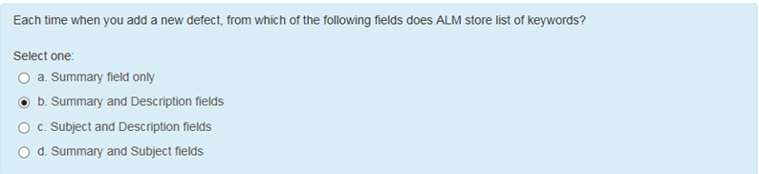

1. a user can add a new defect to an hp alm project from any module at any stage of the testing process – True
2. refers to making software specifically designed for a specific locality – localization
3. which of the following is correct defect module – true

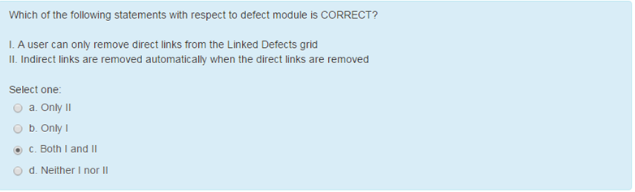

1. You can add a new defect to a Quality Center project from any module at any stage of the testing process – true
2. Requirement topics are recorded in the Requirements module by creating a requirements – requirement tree
3. Challenges of mobile testing

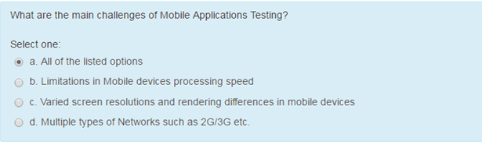

1. valid option that lists out all architectural components of alm

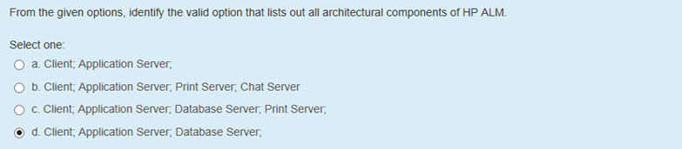

1. features of emulators/simulators mimic

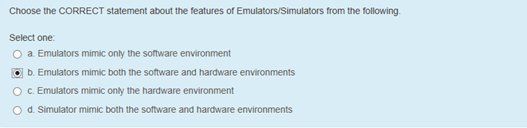

1. Testing conducted to evaluate the compliance of a system or component with specified performance requirements – Performance testing
2. in defects module while reviewing and deciding which new defects need to be fixed - Release and cycle

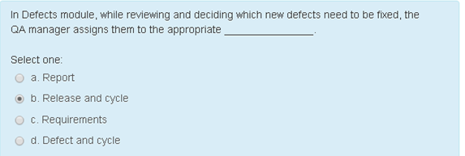

1. mvc is a widely adapted framework for which programming language – Java/all
2. a model could be a single object or a structure of objects – True
3. visual representation of a model - View
4. The **model** does NOT **depend** on the **controller** or the **view – True**
5. The View in MVC sends the button click actions to Model – false
6. Too many database locks

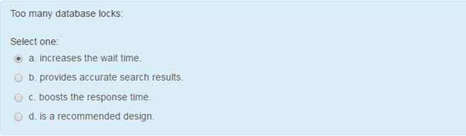

1. Parameters measured during load test

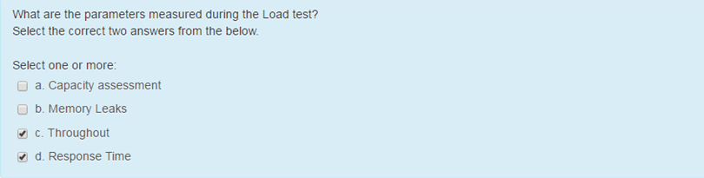

1. MVC web architecture is basically the interaction between browser, page and database – true or false
2. MVC architecture pattern is widely used for developing which of the below applications

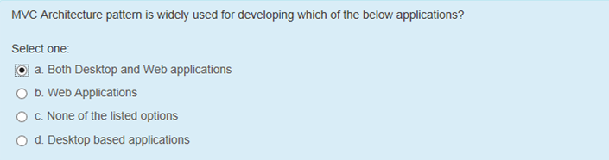

1. MVC framework executable at client level

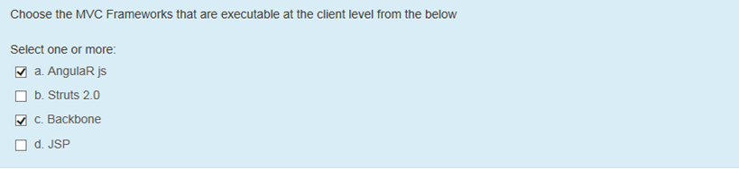

1. Load/demand refers to

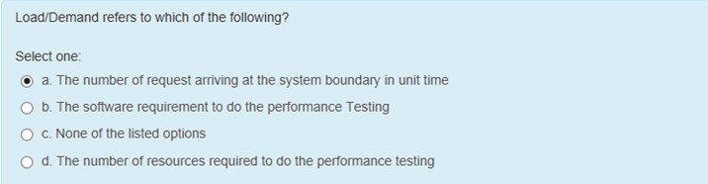

1. Endurance test helps to find memory leaks – True
2. Robotium supports ios and android automation – false
3. In some case controller and view can be same object – True
4. mvc software architecture pattern for developing windows application. handled by 3 objects – false
5. features of security testing - 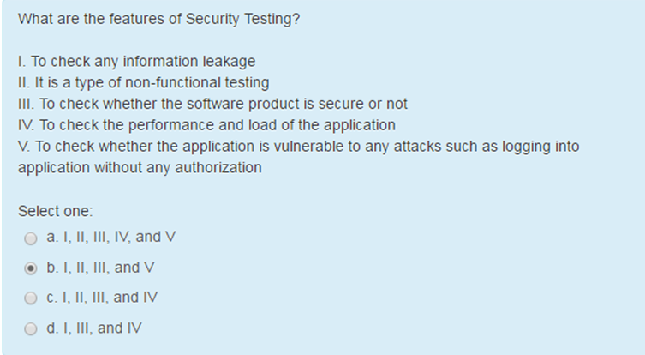
6. open source functional testing tool for os android using record and playback

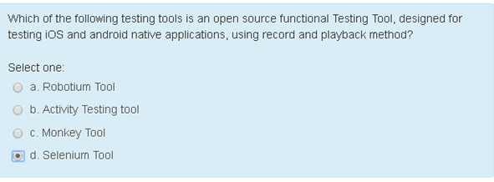

1. Not a valid category in performance engineering

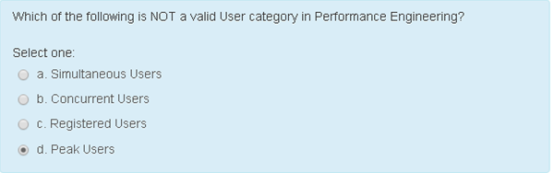

1. Performance testing is performed to address – a c d

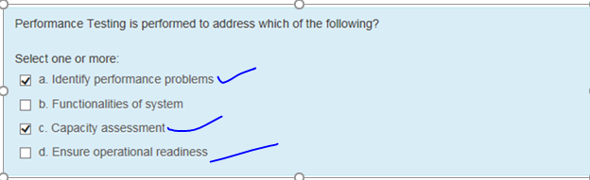

1. Load/demand are which of the following types

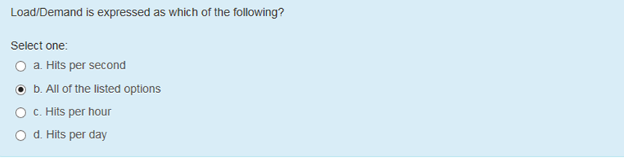

1. choose the tool to verify the text content scaling

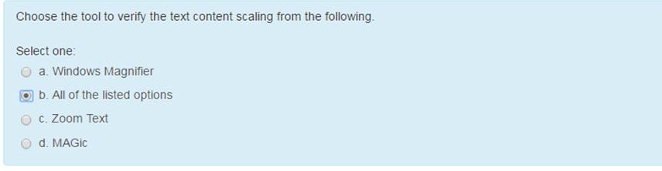

1. Risk profiling can be done at which phase of SDLC

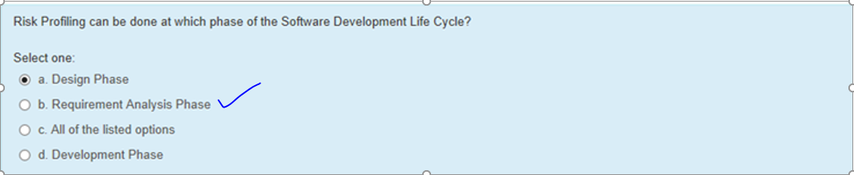

1. Source code analysis is done at which phase of sdlc

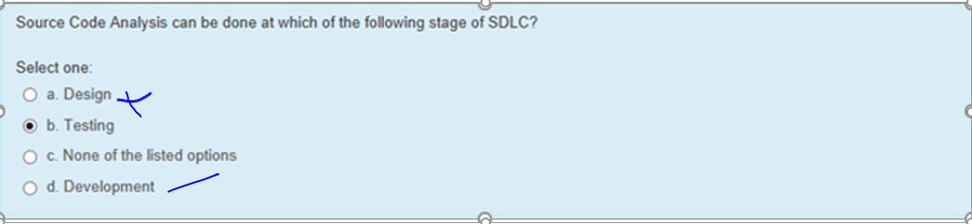

1. Ethical hacking

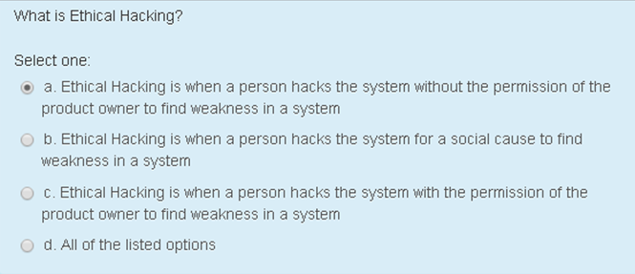

1. ataas how units are calculated

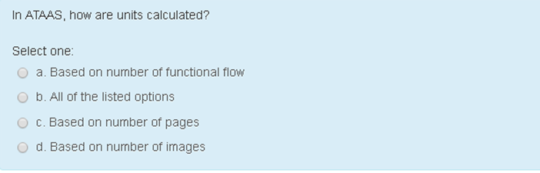

1. accessibility guidelines

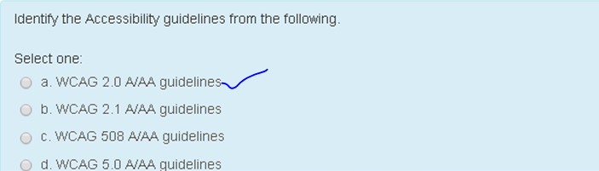

1. assistive tool for visually challenged users

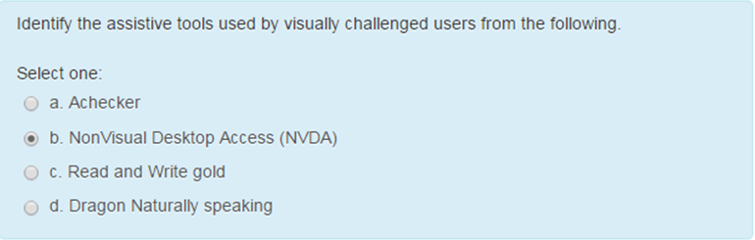

1. why is it important for programmers to use object oriented programming to develop computer systems

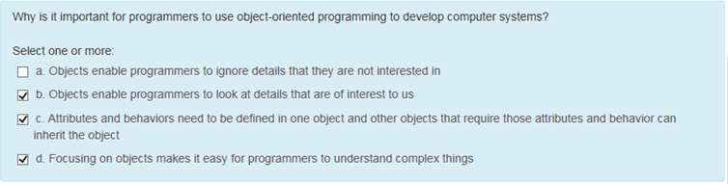

1. 2 things require to define a object

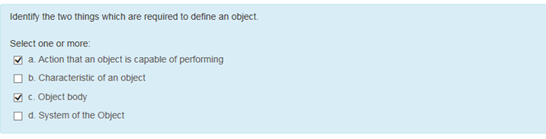

1. In shift left testing is usually carried out waterfall

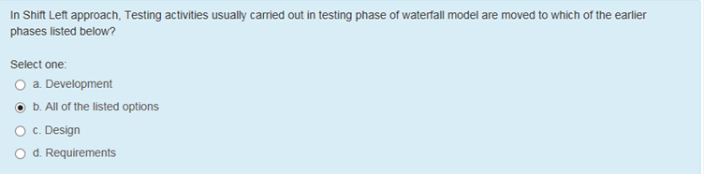

1. Abstract method can be called within a program – true or false
2. Which feature of object oriented programming allows one object to receive attributes and behaviors of another object

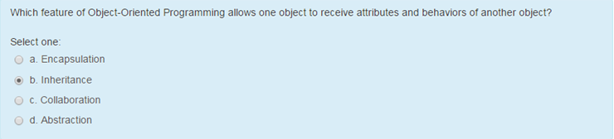

1. In shift left Qa is involved in all the phases of sdlc like 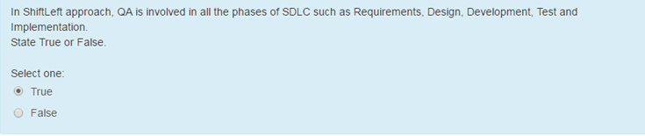
2. technique used to link together the related attributes and procedures to form any object

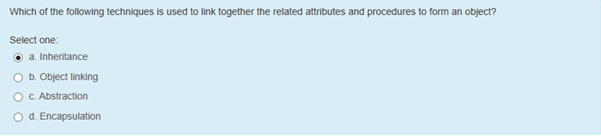

1. in shift left approach even automation and non functional testing plans can get started in early phases like requirements or design phase – True /false
2. name of cognizant tool that helps in modelling the requirements into activity diagram and helps automate test case generation and regression suite identification using in built

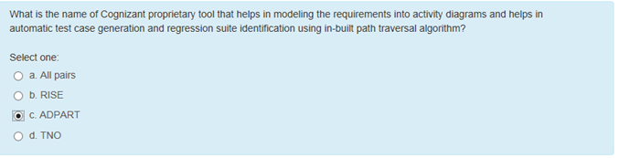

1. in c++ and java languages, which keyword is used in the declaration to create a virtual method without any body

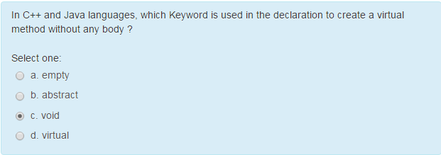

1. functional relationship between two or more entities that are not hierachichally related to each other

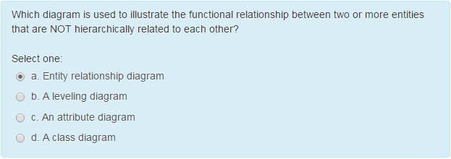

1. students name is an attribute and a students first name and last name are data – true or false
2. polymorphism is implemented by which of the following

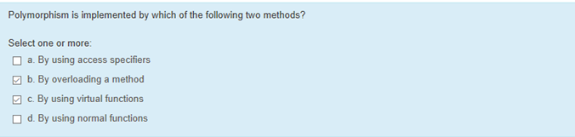

1. an organization of objects in which the relationship among the object is changed over a short time frame is

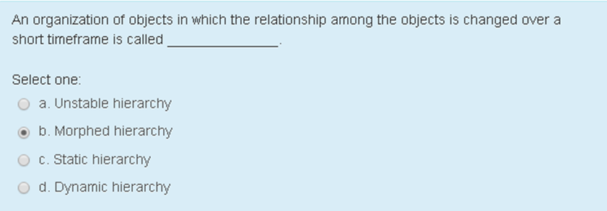

1. An abstract method cannot be called within a program or called directly by a sub class- true or false
2. structural format of soap message version 1.1 mandatory element

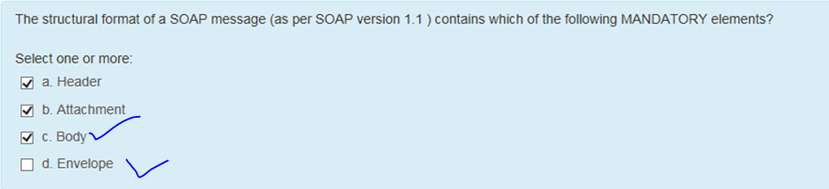

1. Registry services such as managing information about service providers, service implementations and service metadata is provided by – UDDI
2. Key features of Riskbased testing RBT

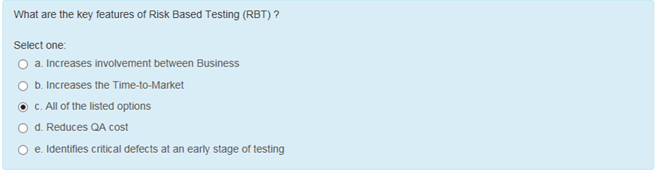

111. right tool or framework that is Cognizant’s utility and is used only for RBT –

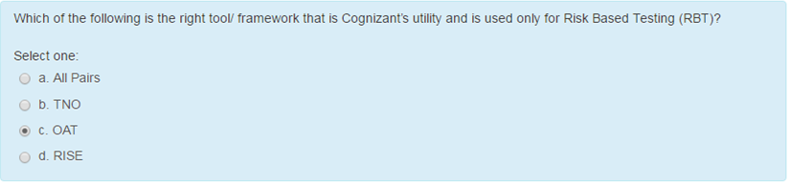

112. ADAPART -

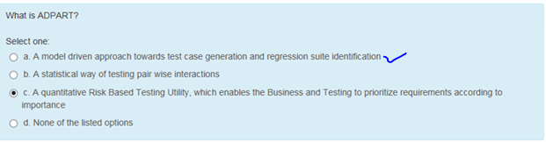

113. problems with conventional testing approach

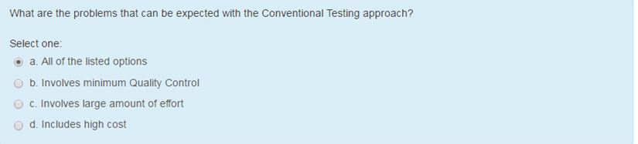

114. risk inspired scenario evaluator is a qualitative risk based testing utility which enables the business and testing to prioritize requirements according to importance – true

115. Key features of adpart

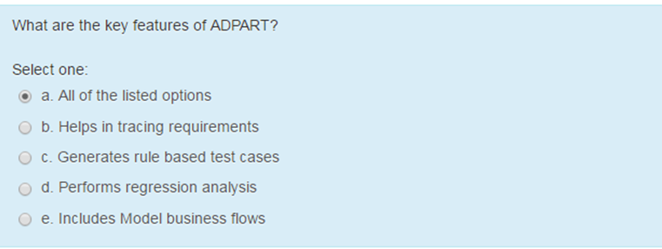

116. how can we improve the quality of application using RBT – a b c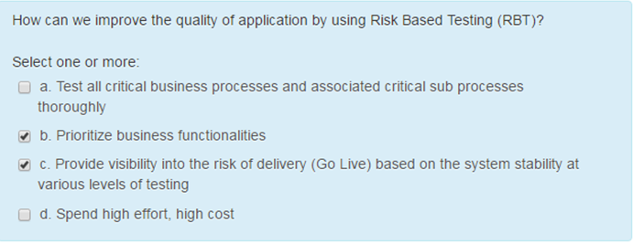

117. probability of failure

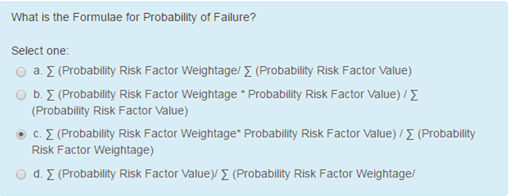

118. OATs is systematic and statistical way of testing pair wise interactions – true

119. why is soap used as a protocol for accessing a web service

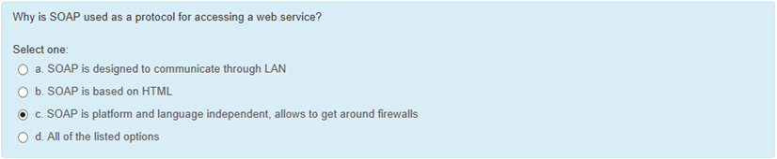

120. items required for RISE workflow

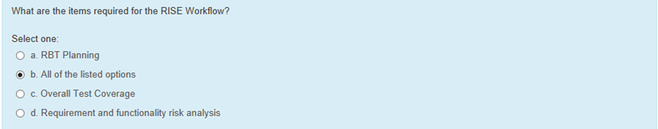

121. requirements are prioritized in conventional testing approach

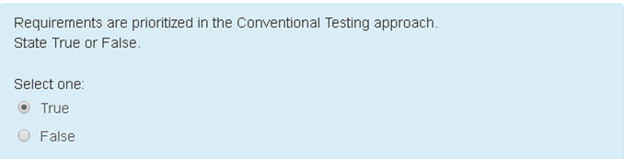

122. probability of failure defines the likelihood of a particular failing functionality and the impact of failure defines the impact of not detecting the failure

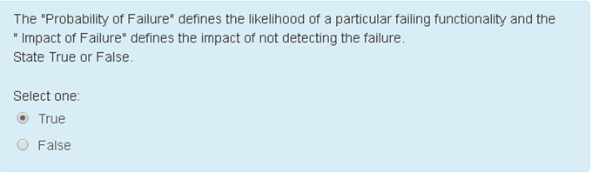

123. risk exposure = impact of failure*probability of failure

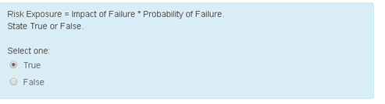

124. RISE = risk inspired scenario evaluator

125. what are the advantages of adopting shift left right concept in testing a product or application

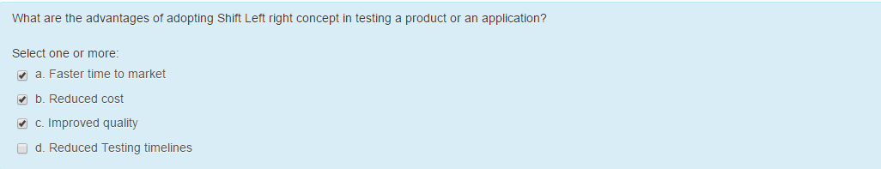

126. valid shift left levers

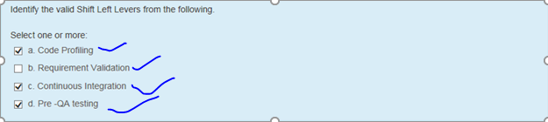

127. shift left model approach of quality assurance is a lot like reactive care – false

128. Component diagrams are useful with teams of larger size - true

129. shift left testing

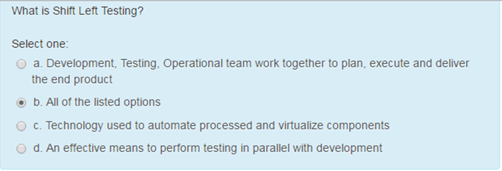

130. Quality of a product is correlated with the number of defects as well as it is limited by time and by money – true

131. structural diagrams best help in budgeting

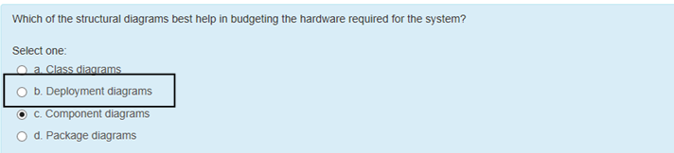

132. sequence diagram is used for functional modeling and activity diagram is used for dynamic modeling – false

133. types of diagrams related to behavioral modeling

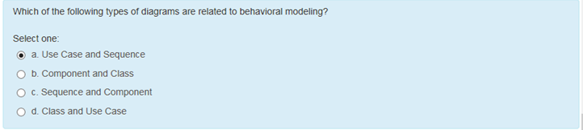

134. not described in a unit test standard

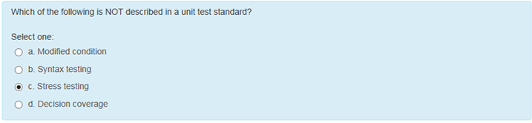

135. UML Unified Modeling language (**UML**) standard language for designing and documenting a system in object oriented manner – true

136. code review performed 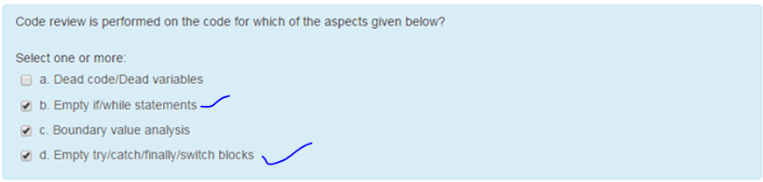

137. 3 goals we focus when creating uml diagram.

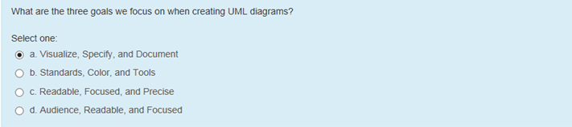

138. what types of errors are missed by black box testing and can be uncovered by white box testing

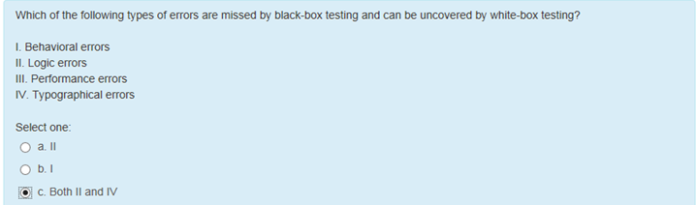139. structural diagrams best defines the replaceable parts of system

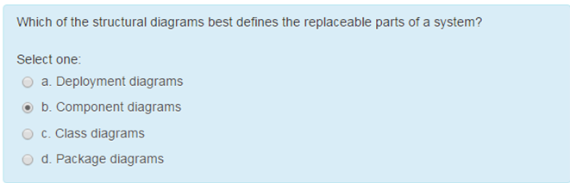

140. use case diagrams specify how a user task is implemented – false

141. odd one 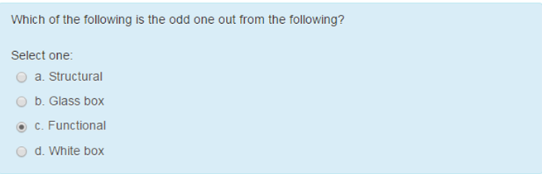

142. for white box testing the basis of test cases is detailed design document – true

143. Code Coverage is used as a measure of what – test effectiveness

144. boundary value analysis can only be used to whte box- false

145. which of the following directory of web service interface is described by wsdl 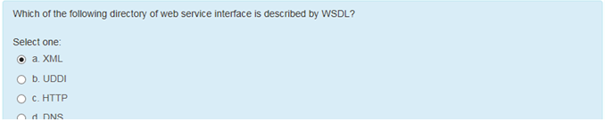

146. inserting some print statements in between to check whether the program control passes through all statements and loops.

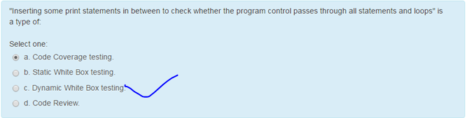

147. white box testing is undertaken to ensure

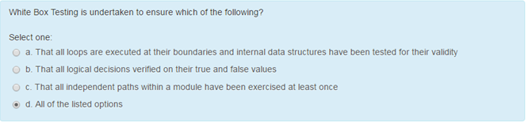

148. when is white box testing performed

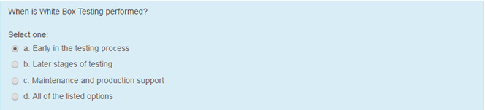

149. white box test design technique

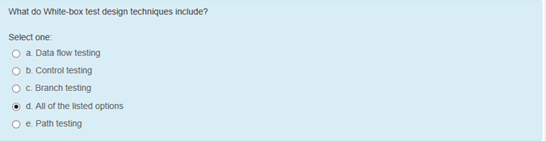

150. white box testing framework

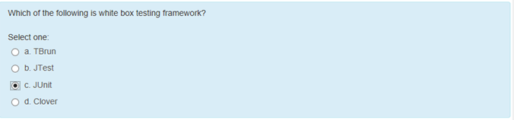

151. white box testing is mainly applicable to which levels of testing

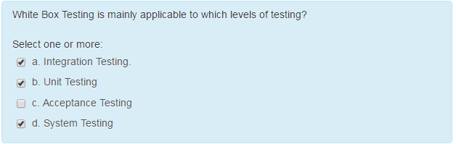

152. not a white box technique

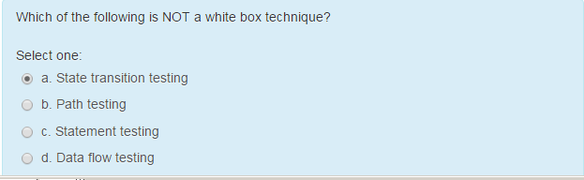 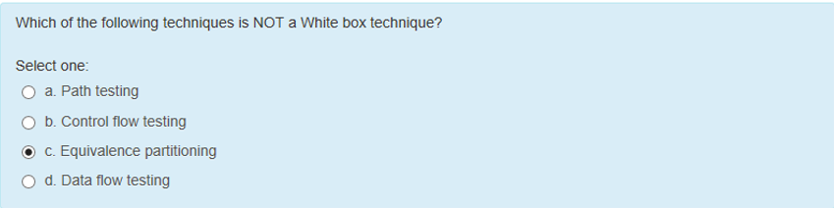

## 153. Coding and decoding, and transporting the data is performed by -

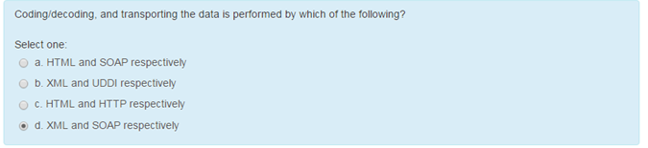

154. which is true rpc w3c

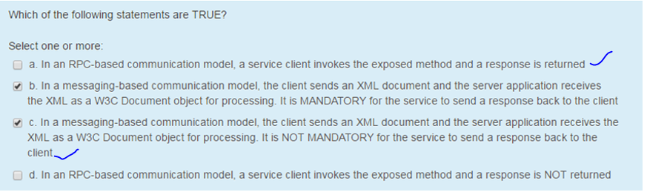

## 155. Which of the following three kinds of data that web services have? -

shared data, pre-session data and temporary data

156. not major element of wsdl document that describes a web service

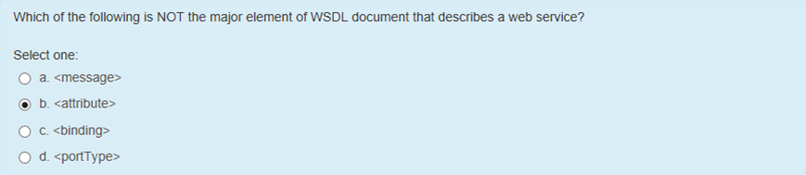

157. base specification of wsdl defines which of the following wsdl binding extension 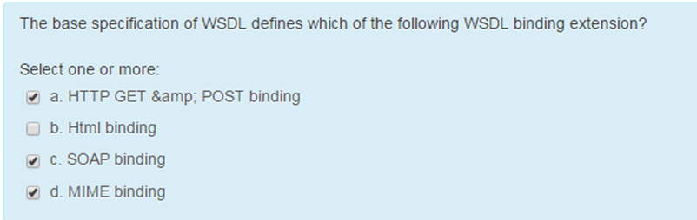

158. the basic data model used in uddi consists of a hierarchy of basic data types which are defined through xml schemas

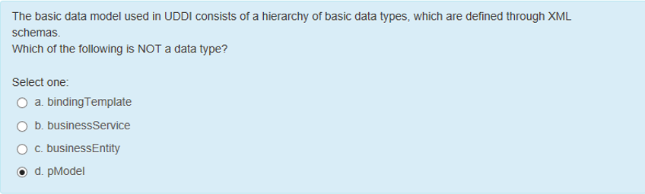

159. which of the given methods describe static testing

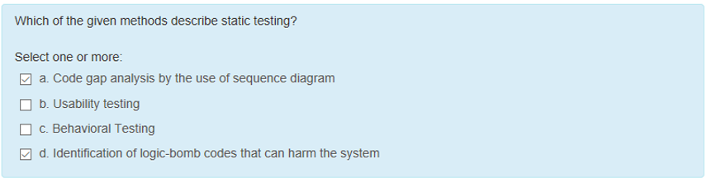

160. Regression testing can be performed as

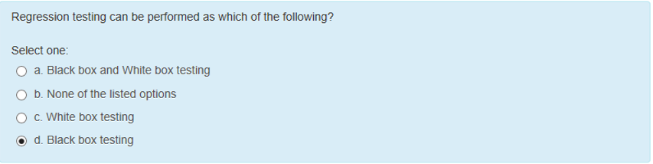

161. Project team should involve testing team during code walkthrough and review activity is a prerequisite shift left lever

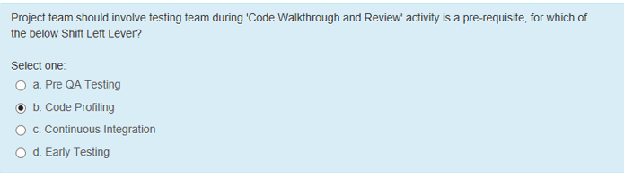

162. what would a super class contain

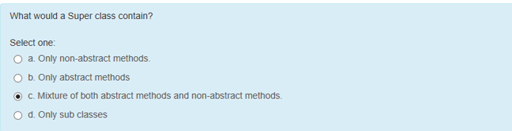

163. automation of build and deployment process which in turn trigger automated smoke test 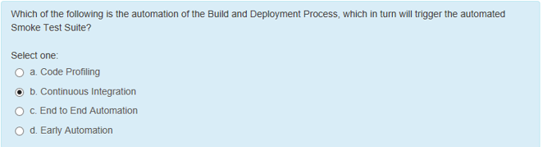

164. response time is not the most important criteria for load test

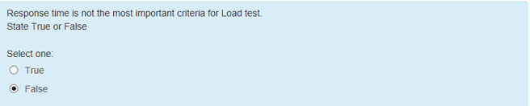

165. cognitive disability

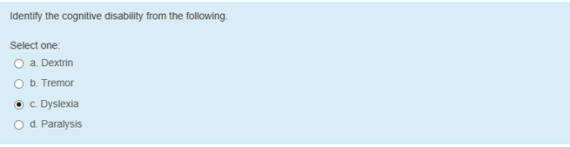

166. integrated development environment that manages your application projects and lets to edit,compile ,run and debug

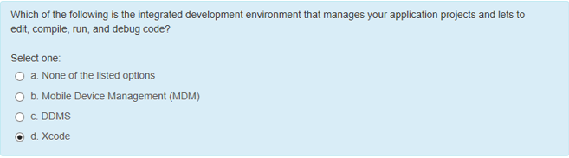

167. a good automation script should be able to run many times without human intervention – true

168. cannot be considered for automation

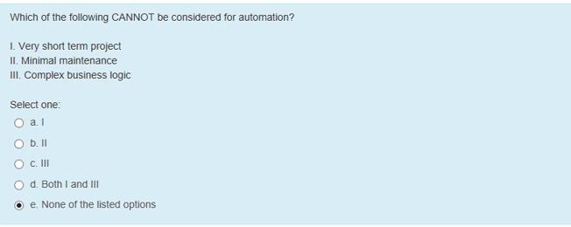

169. product backlog

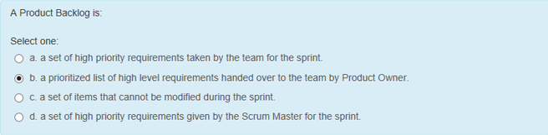

170. valid inputs for sprint planning meeting

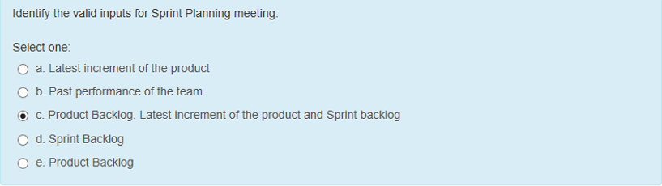

171. which agile methodology has stop starting start finishing as one of the key philosophies

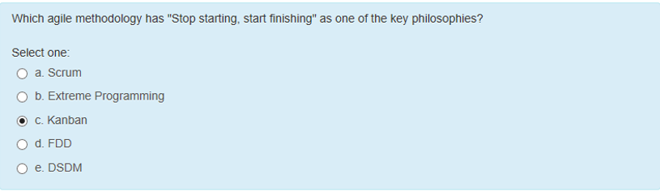

172. not the features of good framework

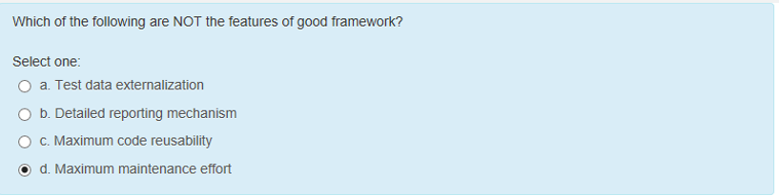

173. automation framework enables which of the following test automation

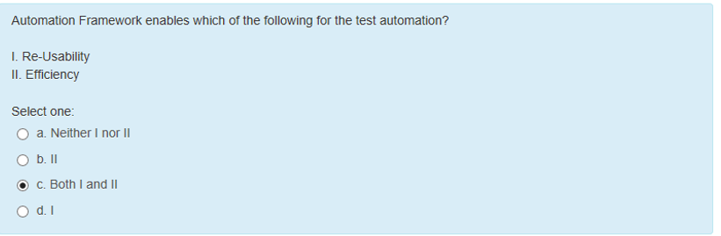

174. automation framework is an replacement for automation tool – false

175. speed to market is a competitive advantage – true

176. which of the following statements wrt defect module is correct

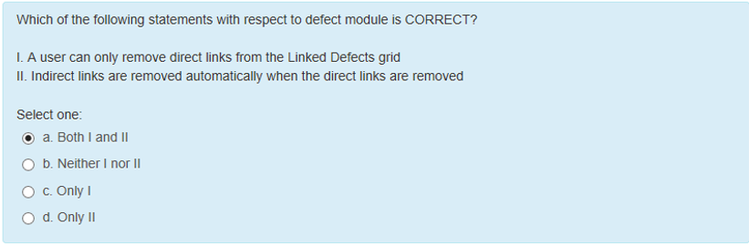

177. iphone simulator does not emulate an iphone processor, disk drive or memory constraints – true

178. model view controller represents the following in the Mvc application

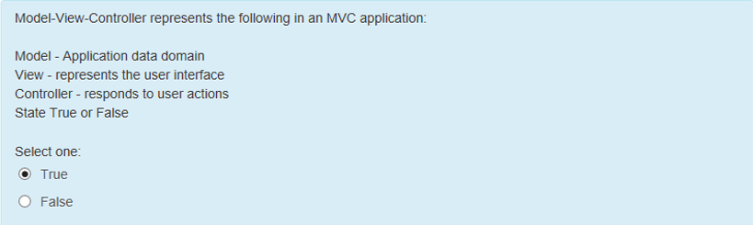

179. load test is done to assess the stability and reliability of system – false

180. load/demand are which of the following types

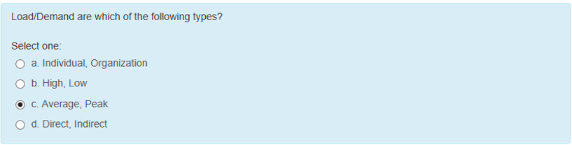

182.

181. which diagram is used to simplify the overall understanding of a complex application 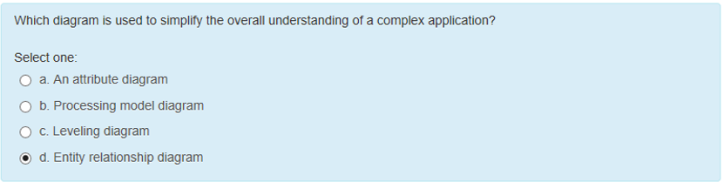

182. objective of carrying defect prevention activities 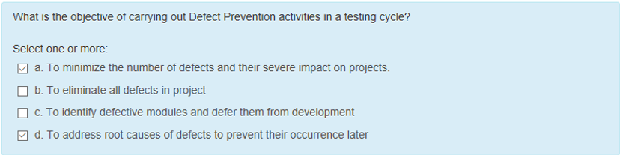

183. shift left is to enable early defect detection – true

184. why might you place an annotation or note on a diagram

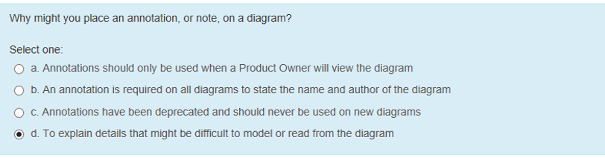

185. the process of examining the source code of a project by unbiased engineer to validate the design and implementation of the product at the most basic level is called

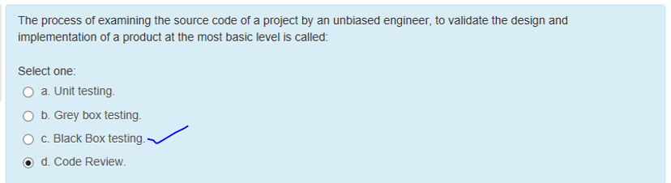

186. what is the type of testing employed in below scenario. Codes for two units/modules are studied

codes for two units/modules are studied (White Box Testing method) for designing test cases and actual tests are conducted using the exposed interfaces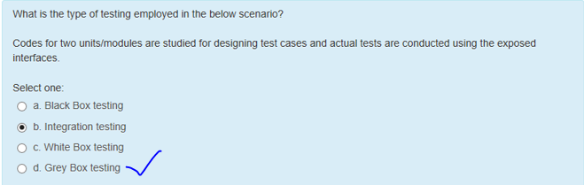

187. which of the following is white box testing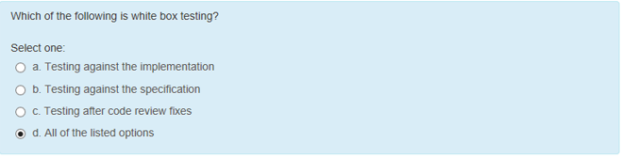

188. which of the following is a directory service where enterprises register and search for web services

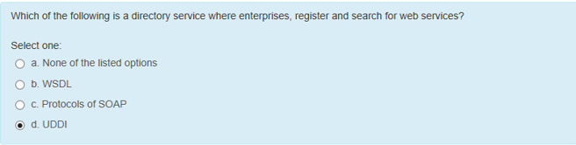

189. what are the different sources of knowledge for white box testing

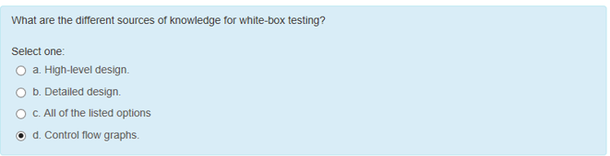

190. whitebox testing = unit testing – true

191. interactions between objects take place in which diagram 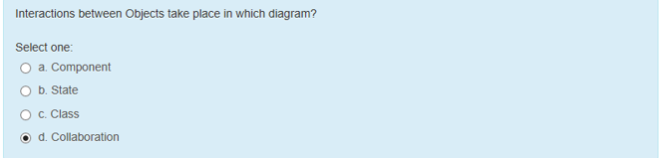

192. what are the type of inheritance in which a child inherits from multiple parents but no relationship exists among those parents 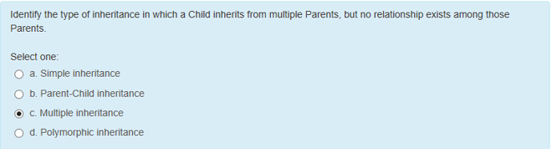

193. requirement analysis, test planning 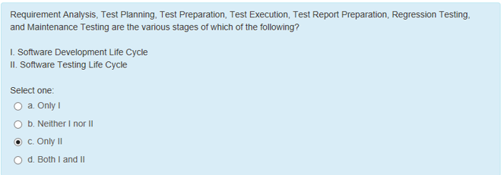

194. non functional test covers

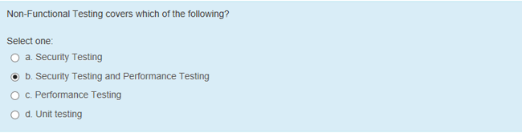

195. Prerequisites of windows 7 emulators

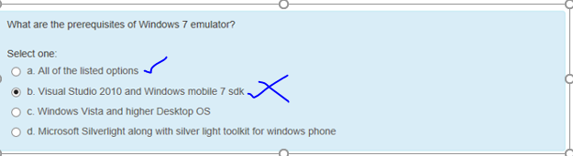

196. choose the statements that apply to controller

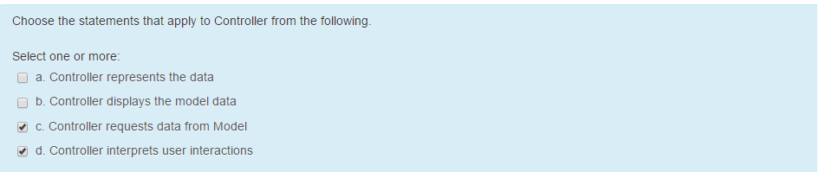

197. benny has created

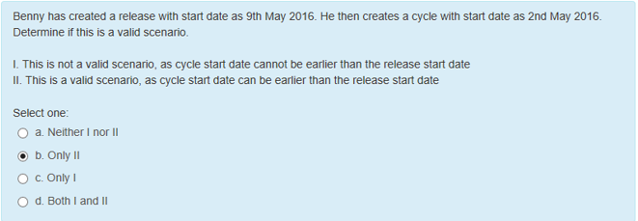

198. in scrum it is recommended

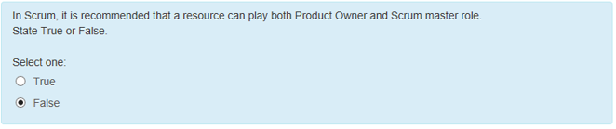

199. traditional pm and agile pm

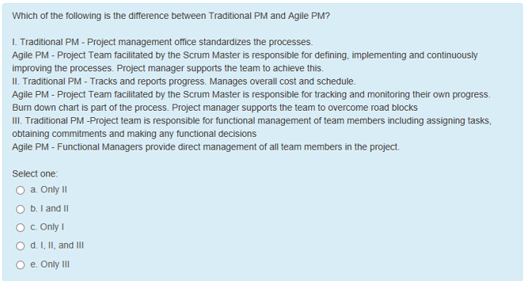

200. in scrum a chicken is

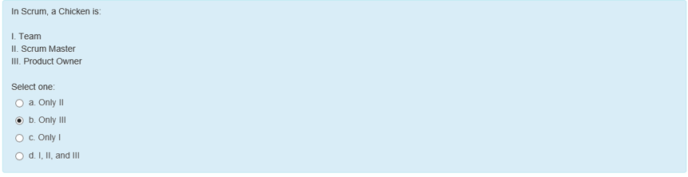

201. in which type of security testing automated tools

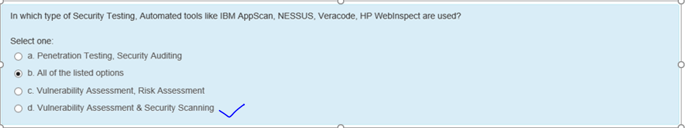

202. correct sequence of activities involved in security testing

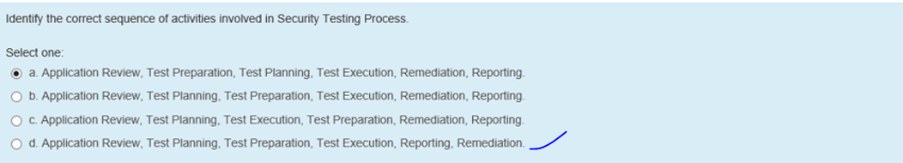

203. base class is the term used in java to refer to a parent class and derived class 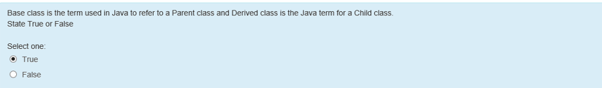

204. ample oppurtunity fine tuning adjust

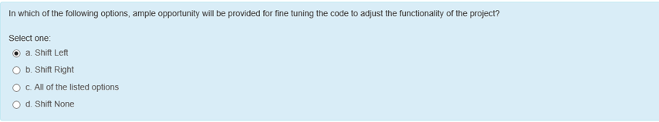

205. what organization manages uml specification today

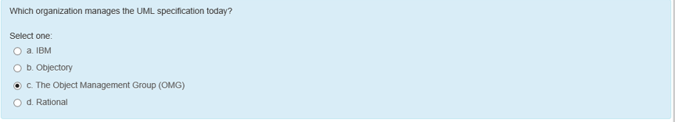

206. web services describe architecture based

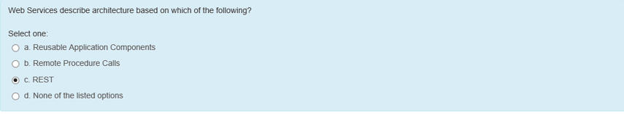

207. which actor is

A programming language

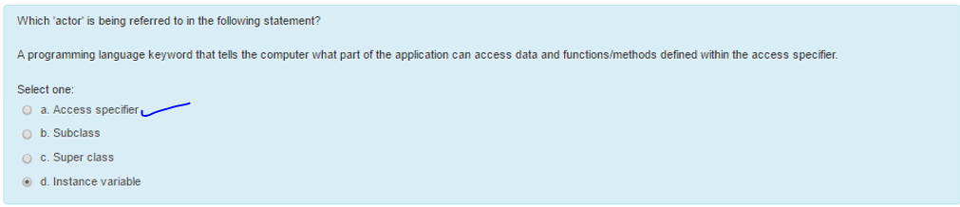

208. not suit automation framework

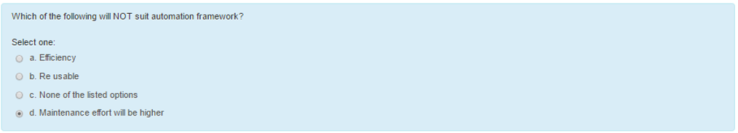

209. golden rule for mvc

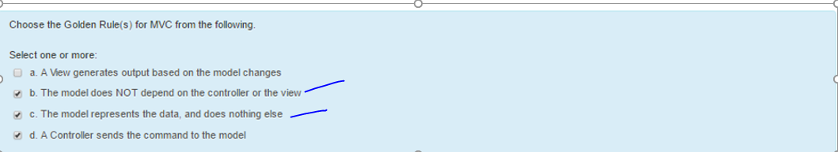

210. which app is built for a specific platform sdk tools languages

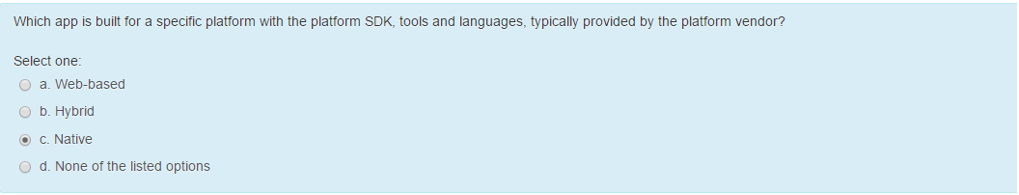

211. MVC framework adapted java j2ee

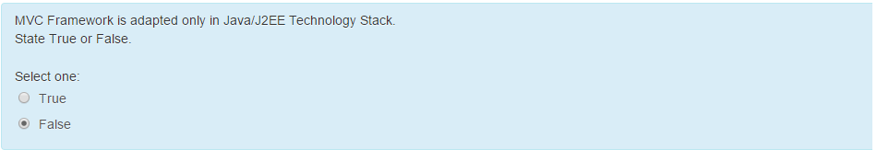

212. reasons for hardware bottleneck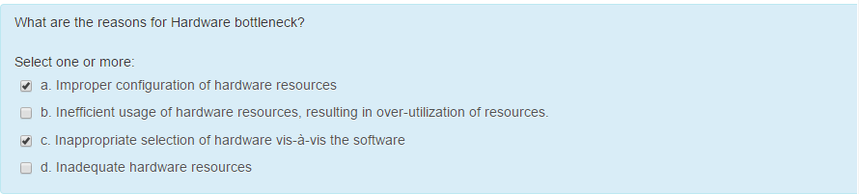

213. threat modeling is performed at 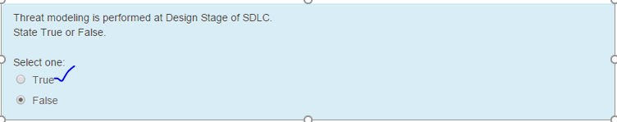

214. relationship dependency

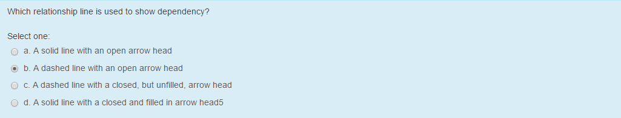

215. service transport xml messaging

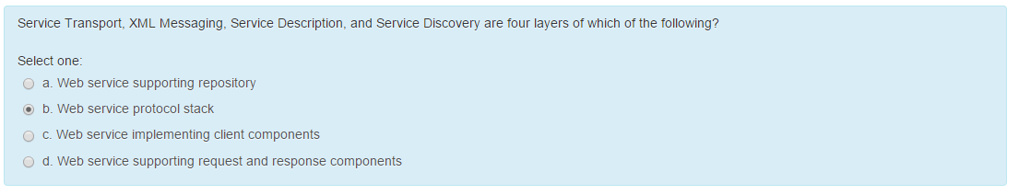

## Agile

Recommended that a resource can play both product owner and scrum master role.

Ans: False

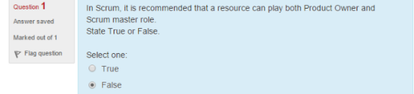

Who is Responsible for not delivering the complex requirements on time.

Ans: E

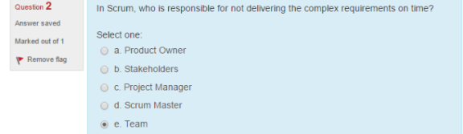

What is scrumban?

Ans: B

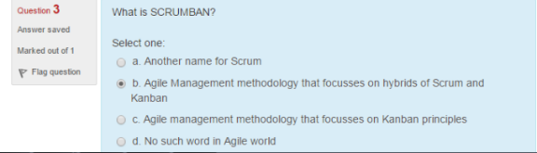

Scrum and Kanban can be used at the same time ?

Ans: True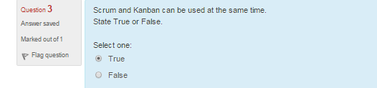

Which of the following meetings is not part of the scrum?

Ans: D

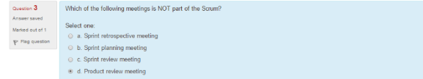

Velocity is a measure of which of the following?

Ans: A

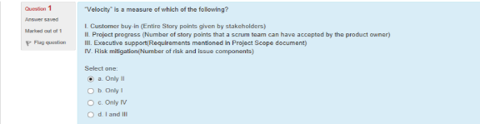

Which of the following is the difference between traditional pm and agile pm?

Ans: E

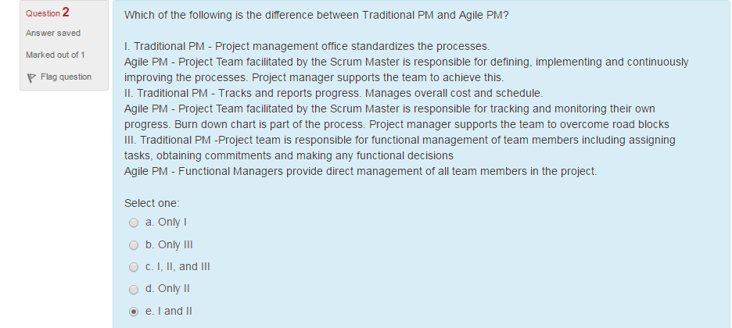

Identify 3 charcteristivs of Kanban from the following?

Ans: C, D, E

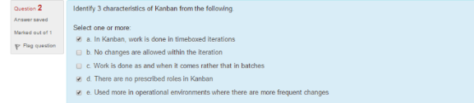

Identify an agile methodology which mandates engineering practices the automation.test driven development etc.?

Ans: C

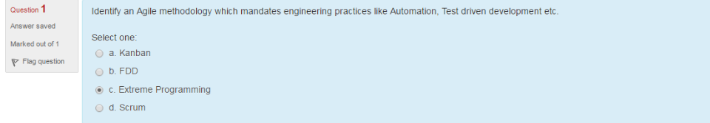

Extreme programming teams are amenable to changes within a sprint?

Ans: True

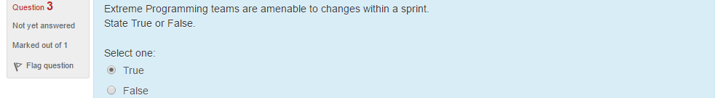

Which of the following is the recommended approach to design in an agile project?

Ans: D

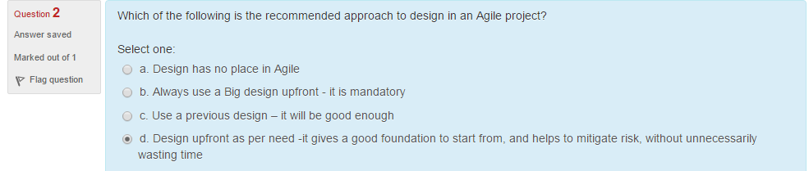

When can a userstory be accepted in a sprint?

Ans: B

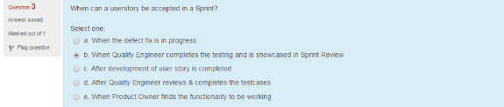

In scrum when is testing done?

Ans: B

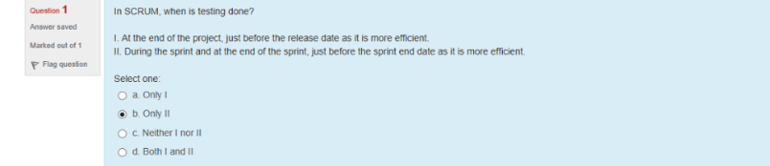

Which of the following statements are true with respect to scrum meeting?

Ans: C

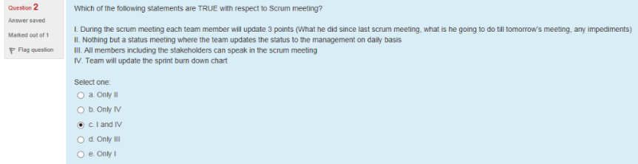

A product backlog is?

Ans: B

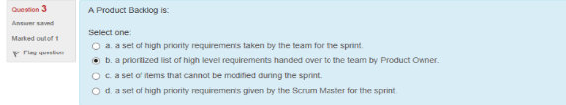

--------------------------------

Identify the valid inputs for sprint planning meeting?

Ans: B

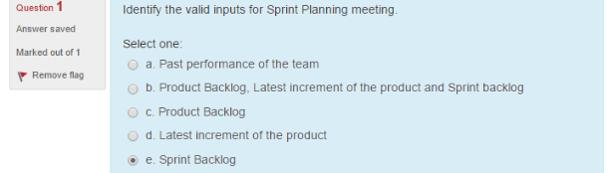

In scrum , a chicken is:

Ans: A is incorrect

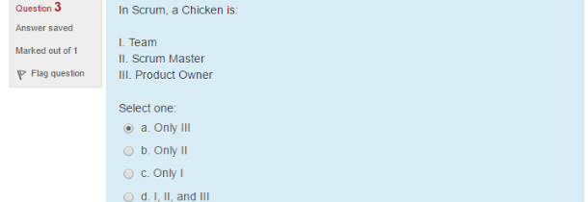

Scrum is

Ans: B

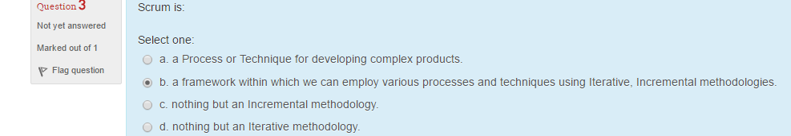

How should work be allocated to the team in an agile project?

Ans: D

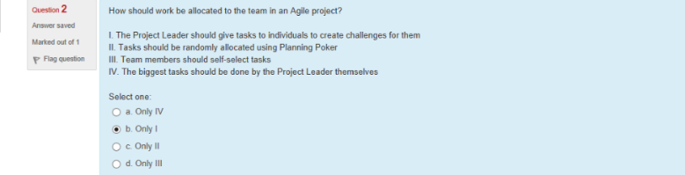

## Automation

On what basis will you choose a framework for your tool

Ans: A

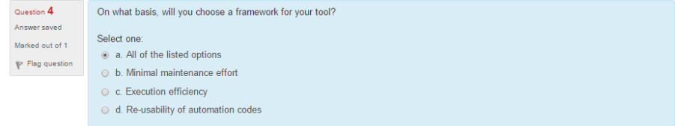

Automation framework enables which of the following for the test automation?

Ans: D

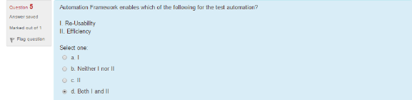

It is possible to automate an application with automation framework but without using any tool?

Ans: False

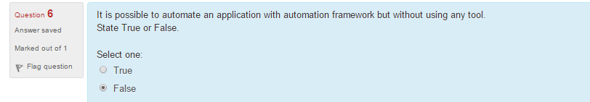

In which of the following conditions does automation score over manual testing?

Ans: D

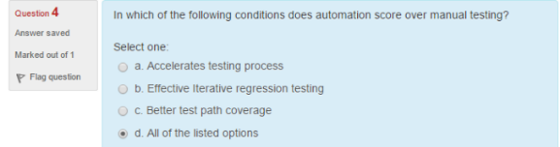

Not the features of good framework?

Ans: D

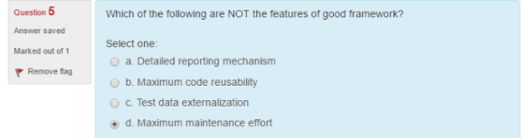

Characteristics of a good automation scripting approach from the following

Ans: A

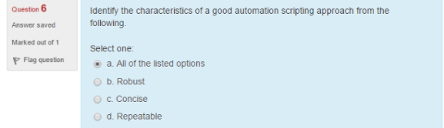

A good automation script should be able to run many times without any human intervention

Ans: True

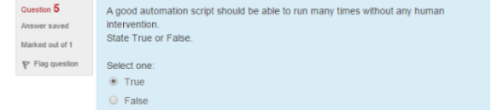

Basic necessities for an automation approach?

Ans: B

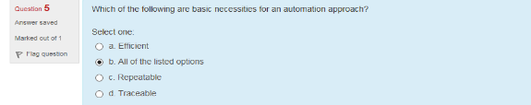

Automation framework is a replacement for an automation tool

Ans: False

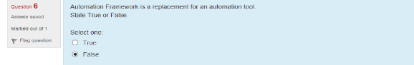

Potential benefits of an automated testing is usually outlined In which of the following phase?

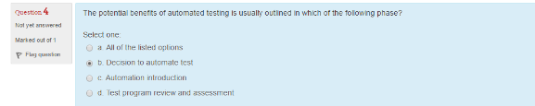Ans: B

Effects of not using automation framework during automation

Ans: D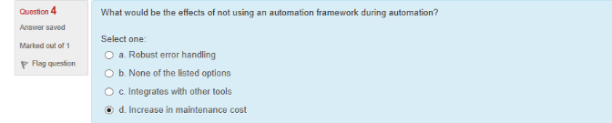

Automation framework enables which of the following for the test automation

Ans: B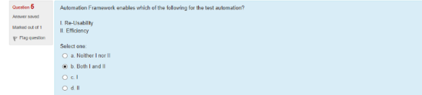

Not suit automation framework?

Ans: A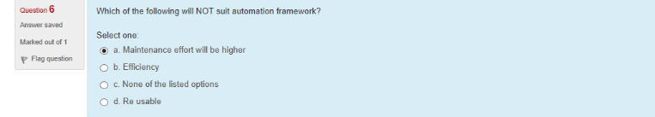

Best way to reduce automation costs with valid assumptions

Ans: B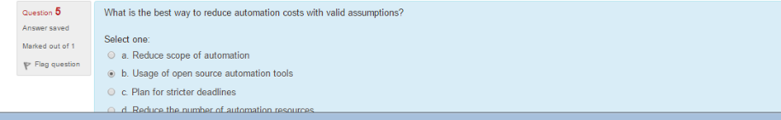

Craft framework

Ans: B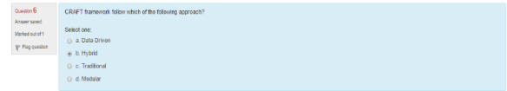

-----------------------------------------

What would happen if,you are not using automation framework?

Ans: A

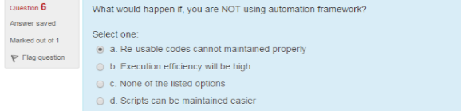

Automation testing increases which of the following for an application?

Ans: D

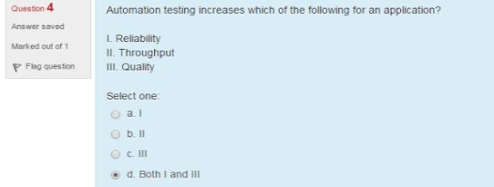

Why do you need to go for automation framework?

Ans: D

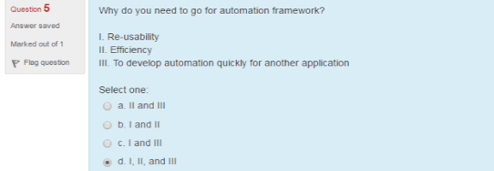

Which of the following will not suit creation of automation test scripts?

Ans: B

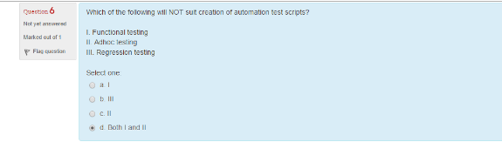

Principles which should be kept in mind while developing automation framework ?

Ans: A, C, D

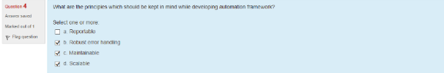

## DevOps

Way that DevOps can actually increase your system security?

Ans: D

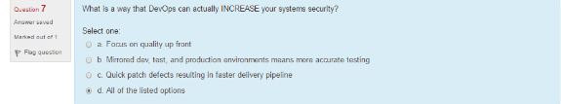

2 core operation of devops with respect to application infrastructure?

Ans: C, D

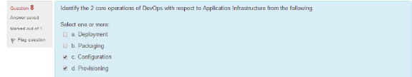

Diff between over-production waste and over-processing waste?

Ans: D

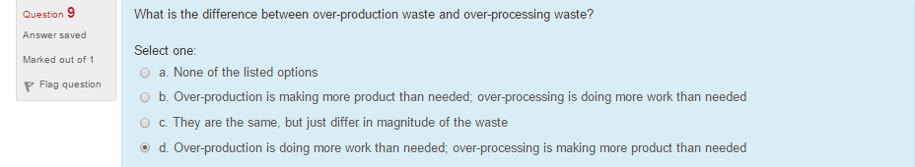

Continuous deployment differ from continuous delivery?

Ans: D

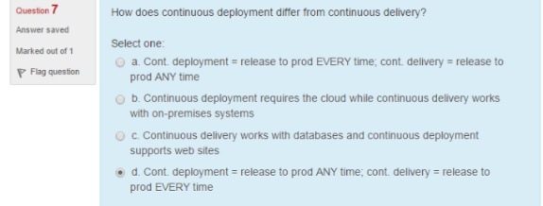

Core operation of devops with respect to application development

Ans: A, C, D, E

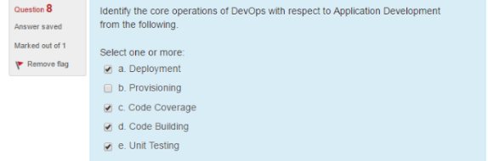

Continuous testing in devops?

Ans: D

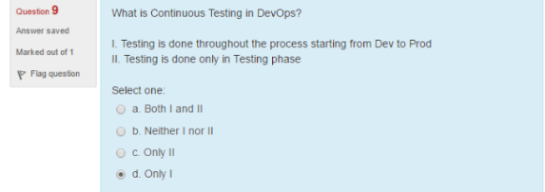

Role does source control play in a devops org?

Ans: A

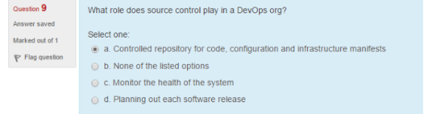

Key aspects of principle behind devops?

Ans: A

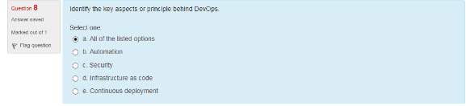

How would you categorize the waster of having multiple issue tracking systems?

Ans: A

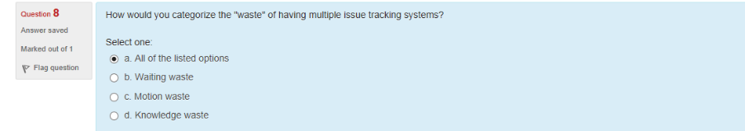

Inconsistent environments can be bottleneck?

Ans: True

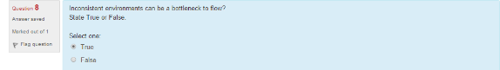

Successful devops requires a new team dedicated to carrying out deployment and optimization tasks

Ans: True

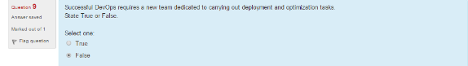

Speed to market is a competitive advantage

Ans: True

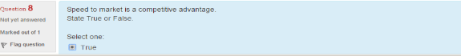

Way that devops can actually increase your systems security

Ans: D

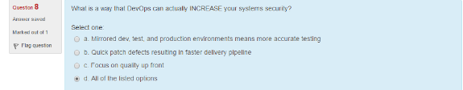

Popular devops tool

Ans: A, B, D

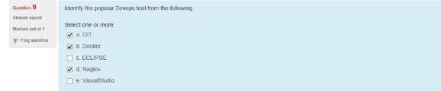

Collaboration tool makes the most sense for persistent information

Slack is incorrect answer

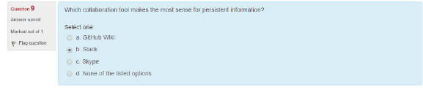

## HP ALM

THE project generated in hp-alm can’t be customized as per the template required for the report.

Ans: False

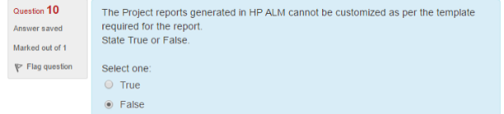

.Each time when you time add the new defects –ALM store list of keywords

Ans: A

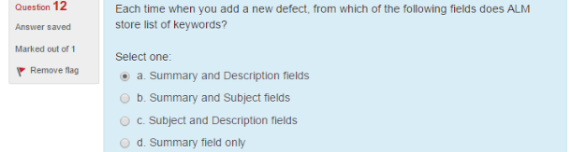

In defect module while viewing and deciding which new defects to be fixed the QA manager assigns them to appropriate.

Ans: D

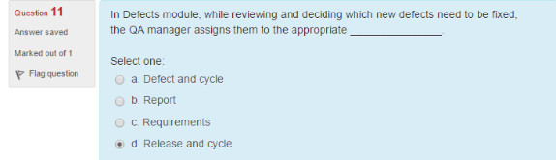

From the given options identify the valid sequence that a defect can traverse through

Ans: A, C, D

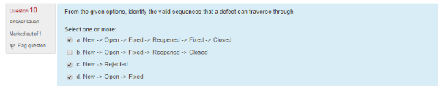

From the given options identify the options that list out architectural components of HP ALM.

Ans: A

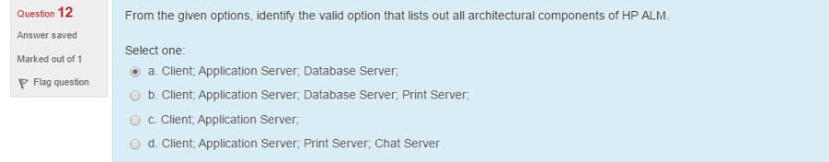

A defect can be linked to an entity like run step or test or run step

Ans: C

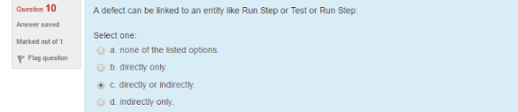

if a user wants to display data from various modules which type of graph should the user choose from the options liasted below?

Ans: A

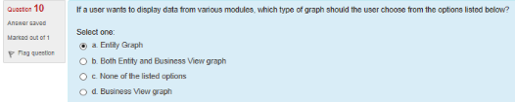

Which of the following statements with respect to defect module is correct

1 user can only remove direct links from the linked defects grid

2 indirect linkns are removed automatixally when the direct links are removed

Ans: D

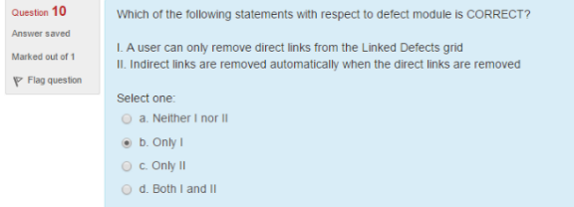

Benny has created a release with start date as 9th may 2016. He then creates a cycle with start date as 2nd may 2016 .determine the valid scenario

Ans: C

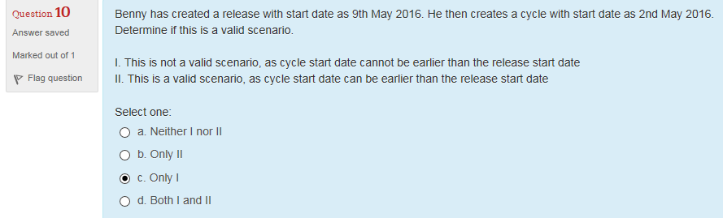

In the requirements module of h palm, requirement related topics are recorded by creating which of the following?

Ans: B

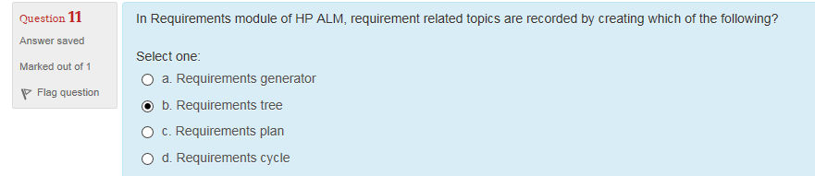

A user can add a new defect to an hp alm project from any stage of the testing process

Ans: True

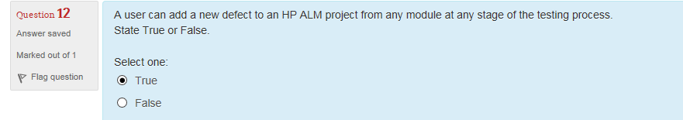

## Mobile Testing

Robotium is Android only.

Robotium supports ios as well as android app automation

Ans: False.

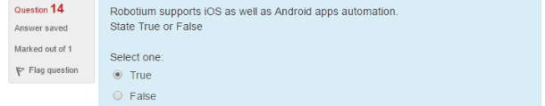

Which of the following are like native apps which run on the device and is written with web technologies ?

Ans: B

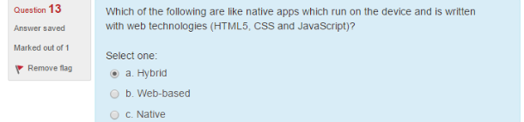

What are the main challenges of mobile applications testing?

Ans: D

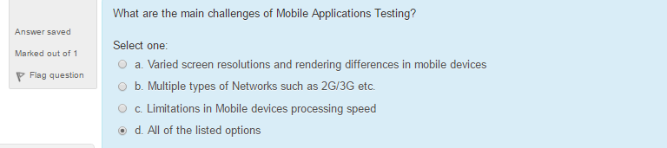

Iphone simulator does not emulate an iphone processor disk drive or memory constraints

Ans: True

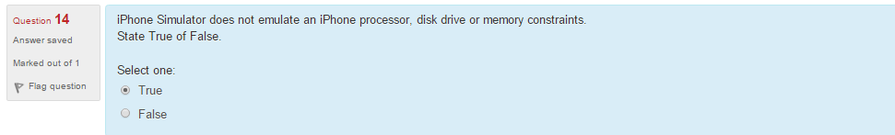

Which of the following is the integrated development environment that manages your application projects and lets to edit complie run and debug code?

Ans: A

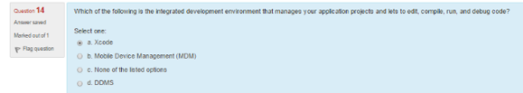

What are the prerequisties of windows 7 emulator?

Ans: A

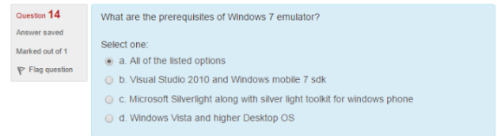

## MVC

Mvc framework that are executable at the client level from the below

Ans: A, C

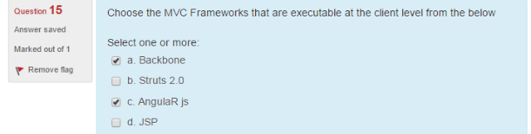

View in mvc sends the button click actions to model Controller

Ans: False

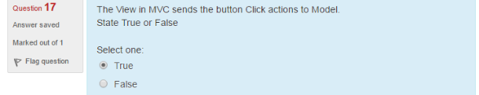

Model_view controller (MVC) is a software architecture pattern for developing windows application

Ans: False

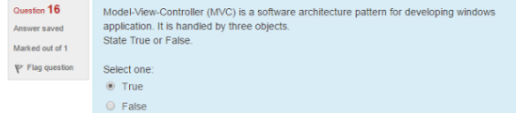

A model could be a single object or a structure of objects

Ans: True

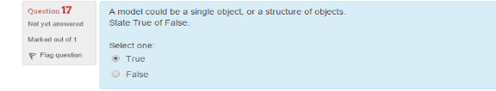

Model does not depend on the controller or view

Ans: True

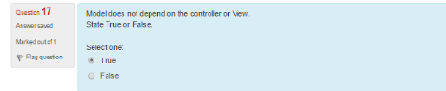

View is the visual representation of a model

Ans: B.

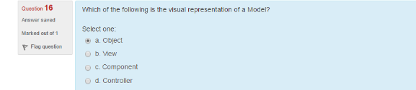

Choose the golden rules for mvc

Ans: All four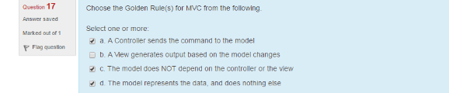

Statements that apply to controller

Ans: B, C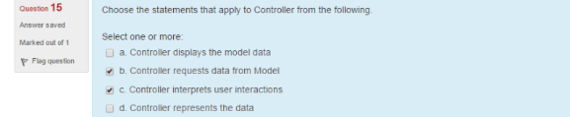

Controller and view can be same object

Ans: True 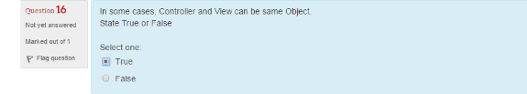

Model-view-controller represents the following in a mvc application

Ans: True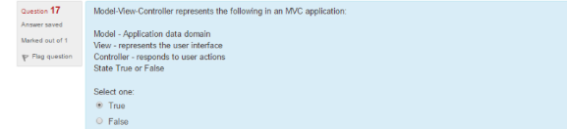

MVC Architecture pattern is widely used for developing which of the below

Ans: B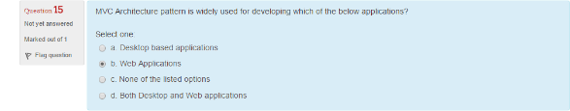

The mvc web architecture is basically an interaction between browser, page and database

Ans: False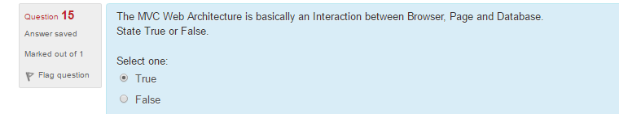

MVC framework is adapted only in java/j2ee

Ans: False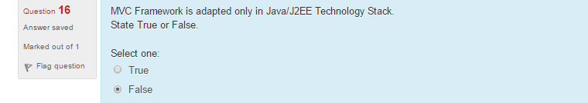

MVC is widely adapted architecture framework for which of the programming languages?

Ans: B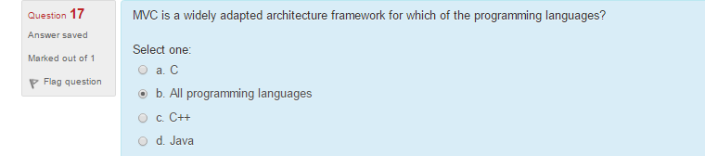

## NFT

choose the non functional testing solutions delivered as part of nftaas from the following

Ans: D

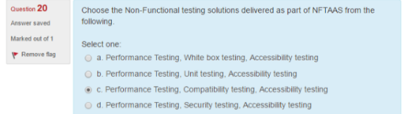

endurance tests helps to find any memory leak issues

Ans: True

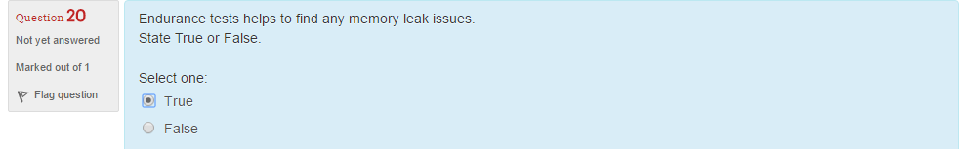

arrival rate represents the number of requests arriving at the system boundary per unit of time

Ans: True

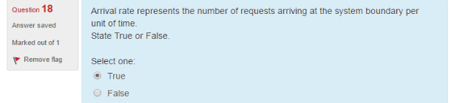

100% cpu utilization for ordinary tasks at a moderate load is considered as which of the following

Ans: D

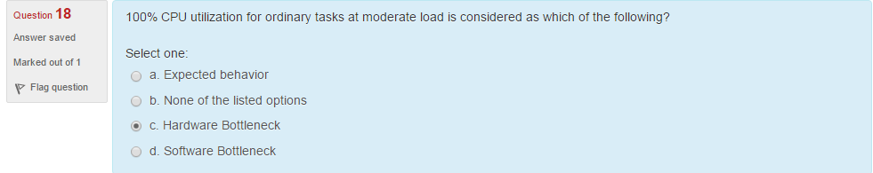

Ans: True

the users who are authorisedto use the system are known as registered users

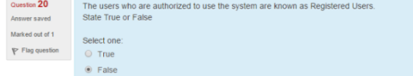

Ans: False

response time is not the most important criteria for load test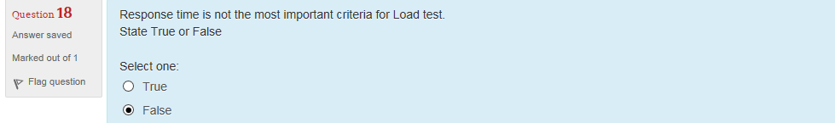

Ans: B

load/demand is expressed as which of the following

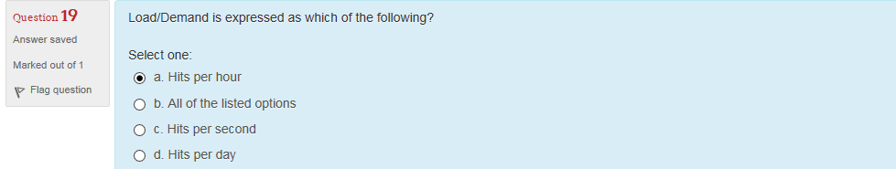

Ans: A

load/demand is refers which of the following

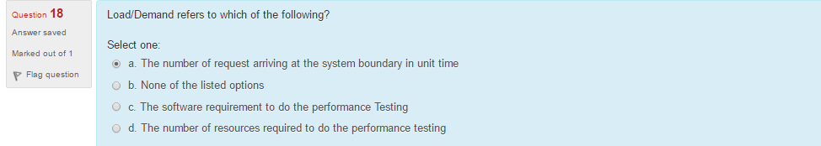

It is hardware bottleneck

Ans: False.

improper configuration of hardware resources is a software bottleneck

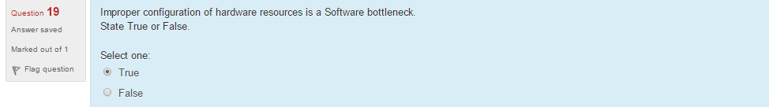

what are the security concepts that cover security testing

Ans: B

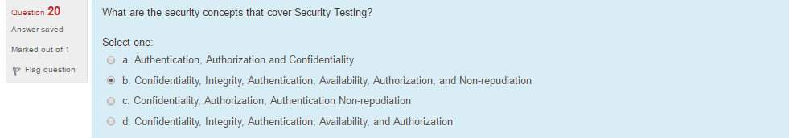

which of the following is a security related test scenario

Ans: B

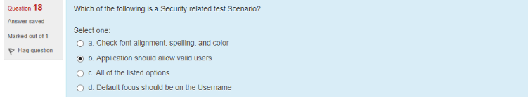

which of the following is not a valid user category in performance engineering

Ans: A

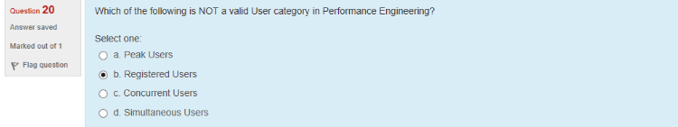

identify the assistive tools used by visually challenged users from the following

Ans: B

